**MTELE5331 - DATA NETWORKING LAB**

**CISCO PACKET TRACER PROJECT**

**High Level Diagram :**

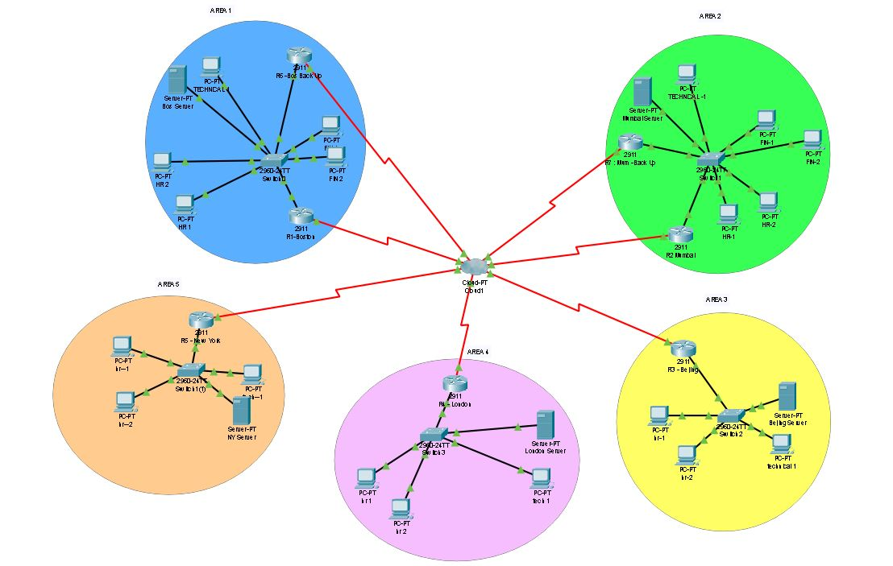

In the above diagram, there are five areas including the backbone area 0 which is represented by the frame-relay. There are two head-quarters with three departments each and they are located at Boston and Mumbai. There are three branches in Beijing, London and finally New York.

The departments are : Technical , Finance and HR departments respectively. Each area has 250 users with redundancy of 85%. Therefore the total number of IP addresses to be assigned is :

250 + 250*0.85 ~= 463 IP addresses.

No. of Routers : 7 ( 2 for back up for HQ)

No. of Switches : 5

No. of Workstations : 19 ( They represent the others in the respective departments)

No. of frame-relay : 1

No. of Servers : 5

This project focuses on communication between all areas effectively and efficiently using OSPF protocols, DHCP allocation to all workstations and maintaining redundancy and secure connectivity using encryption and HSRP.

Network Cost :

Cisco Router (2911) : 795$ * 7 = 5565$

Cisco Switch (2960) : 150$*11 = 1650$

DHCP Server: 600$*5 = 3000$

Serial DCE : 3.5$ per ft

Copper Straight Through : 0.6$ per ft

**Assigning IP addresses and VLANs :**

The task was to distribute 193.168.30.0/19 ( 30 being the last digits of NUID) but it will give us 8190 users which is a lot more than needed. There fore 193.168.30.0/24 is considered which will give us 254 hosts, neglecting the network and broadcast address.

Virtual LANs , fortunately, can be done using just one switch and router if it has enough ports. Here we split the fast-ethernet ports of the switch to the respective vlans using the router’s gigabit-ethernet ports.

There are five areas :

Area 1 : Boston

Area 2 : Mumbai

Area 3 : Beijing

Area 4 : London

Area 5 : New York

**Considering HQ 1 In Boston :**

VLAN 2 : TECHNICAL DEPARTMENT

VLAN 3 : HR DEPARTMENT

VLAN 4: FINANCE DEPARTMENT

In order to assign the IP addresses, DHCP server was used and following is the image containing the IP pools for the respective department :

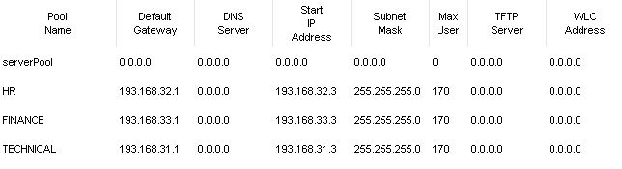

Following are the commands involved in the router creating the respective vlans

interface GigabitEthernet0/0.2

encapsulation dot1Q 2

ip address 193.168.31.1 255.255.255.0

ip helper-address 193.168.31.2

!

interface GigabitEthernet0/0.3

encapsulation dot1Q 3

ip address 193.168.32.1 255.255.255.0

ip helper-address 193.168.31.2

!

interface GigabitEthernet0/0.4

encapsulation dot1Q 4

ip address 193.168.33.1 255.255.255.0

ip helper-address 193.168.31.2

!

**Considering HQ 2 in Mumbai :**

VLAN 2 : TECHNICAL DEPARTMENT

VLAN 3 : HR DEPARTMENT

VLAN 4: FINANCE DEPARTMENT

In order to assign the IP addresses, DHCP server was used and following is the image containing the IP pools for the respective department :

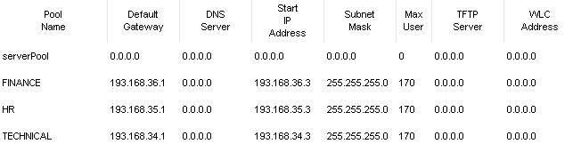

Following are the commands involved in the router creating the respective vlans

interface GigabitEthernet0/0.2

encapsulation dot1Q 2

ip address 193.168.34.1 255.255.255.0

ip helper-address 193.168.34.2

!

interface GigabitEthernet0/0.3

encapsulation dot1Q 3

ip address 193.168.35.1 255.255.255.0

ip helper-address 193.168.34.2

!

interface GigabitEthernet0/0.4

encapsulation dot1Q 4

ip address 193.168.36.1 255.255.255.0

ip helper-address 193.168.34.2

!

**Considering Beijing ( Area 3 ) :**

VLAN 2 : TECHNICAL DEPARTMENT

VLAN 3 : HR DEPARTMENT

In order to assign the IP addresses, DHCP server was used and following is the image containing the IP pools for the respective department :

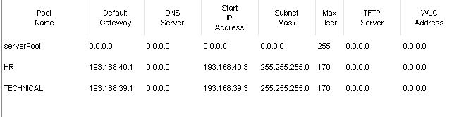

Following are the commands in the router to create the vlans :

interface GigabitEthernet0/0.2

encapsulation dot1Q 2

ip address 193.168.39.1 255.255.255.0

ip helper-address 193.168.39.2

!

interface GigabitEthernet0/0.3

encapsulation dot1Q 3

ip address 193.168.40.1 255.255.255.0

ip helper-address 193.168.39.2

!

**Considering London ( Area 4 ) :**

VLAN 2 : TECHNICAL DEPARTMENT

VLAN 3 : HR DEPARTMENT

In order to assign the IP addresses, DHCP server was used and following is the image containing the IP pools for the respective department :

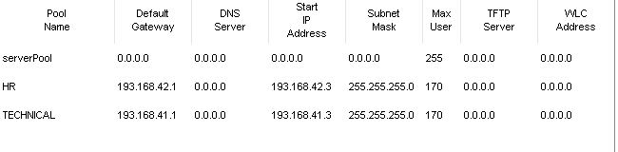

Following are the commands in router, to create the vlans

interface GigabitEthernet0/0.2

encapsulation dot1Q 2

ip address 193.168.41.1 255.255.255.0

ip helper-address 193.168.41.2

!

interface GigabitEthernet0/0.3

encapsulation dot1Q 3

ip address 193.168.42.1 255.255.255.0

ip helper-address 193.168.41.2

!

**Considering New York :**

VLAN 2 : TECHNICAL DEPARTMENT

VLAN 3 : HR DEPARTMENT

In order to assign the IP addresses, DHCP server was used and following is the image containing the IP pools for the respective department :

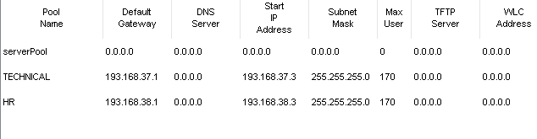

Following are the commands involved in the router for creating the vlans

interface GigabitEthernet0/0.2

encapsulation dot1Q 2

ip address 193.168.37.1 255.255.255.0

ip helper-address 193.168.37.2

!

interface GigabitEthernet0/0.3

encapsulation dot1Q 3

ip address 193.168.38.1 255.255.255.0

ip helper-address 193.168.37.2

!

**Back- up Routers ( HSRP ) :**

HSRP is used mainly to provide back-up to the existing router in cases where there is a damaged link or broken link, the back up router shall act in place of the existing router until the existing router reverts to its original condition.

The main HQs are the ones which have back up routers. The following are the commands for Boston and Mumbai Back-up routers

BOSTON EXISTING ROUTER :

interface GigabitEthernet0/0.2

standby 1 ip 193.168.31.8

standby 1 priority 105

standby 1 preempt

standby 1 track GigabitEthernet0/0.2

!

interface GigabitEthernet0/0.3

standby 2 ip 193.168.32.8

standby 2 priority 105

standby 2 preempt

standby 2 track GigabitEthernet0/0.3

!

interface GigabitEthernet0/0.4

standby 3 ip 193.168.33.8

standby 3 priority 105

standby 3 preempt

standby 3 track GigabitEthernet0/0.4

!

**BOSTON BACK-UP ROUTER :**

interface GigabitEthernet0/0.2

standby 1 ip 193.168.31.8

standby 1 track GigabitEthernet0/0.2

!

interface GigabitEthernet0/0.3

standby 2 ip 193.168.32.8

standby 2 track GigabitEthernet0/0.3

!

interface GigabitEthernet0/0.4

standby 3 ip 193.168.33.8

standby 3 track GigabitEthernet0/0.4

**MUMBAI EXISTING ROUTER :**

interface GigabitEthernet0/0.2

standby 1 ip 193.168.34.8

standby 1 priority 105

standby 1 preempt

standby 1 track GigabitEthernet0/0.2

standby 0 track GigabitEthernet0/0.2

!

interface GigabitEthernet0/0.3

standby 2 ip 193.168.35.8

standby 2 priority 105

standby 2 preempt

standby 2 track GigabitEthernet0/0.3

!

interface GigabitEthernet0/0.4

standby 3 ip 193.168.36.8

standby 3 priority 105

standby 3 preempt

standby 3 track GigabitEthernet0/0.4

!

**MUMBAI BACK-UP ROUTER:**

interface GigabitEthernet0/0.2

standby 1 ip 193.168.34.8

standby 1 track GigabitEthernet0/0.2

!

interface GigabitEthernet0/0.3

standby 2 ip 193.168.35.8

standby 2 track GigabitEthernet0/0.3

!

interface GigabitEthernet0/0.4

encapsulation dot1Q 4

standby 3 ip 193.168.36.8

standby 3 track GigabitEthernet0/0.4

!

**FRAME-RELAY :**

Frame relay is used in WAN to connect to different areas using packet-mode transmission. Here we connect the five areas to a cloud which is the backbone of the entire network.

The frame relay configurations for each router in the five areas are as follows :

Boston ( existing ) :

interface Serial0/0/0

ip address 1.1.1.1 255.0.0.0

encapsulation frame-relay

!

interface Serial0/0/0.102 point-to-point

ip address 193.168.70.1 255.255.255.240

frame-relay interface-dlci 102

clock rate 2000000

!

interface Serial0/0/0.103 point-to-point

ip address 193.168.71.1 255.255.255.240

frame-relay interface-dlci 103

clock rate 2000000

!

interface Serial0/0/0.104 point-to-point

ip address 193.168.72.1 255.255.255.240

frame-relay interface-dlci 104

clock rate 2000000

!

interface Serial0/0/0.105 point-to-point

ip address 193.168.73.1 255.255.255.240

frame-relay interface-dlci 105

clock rate 2000000

!

interface Serial0/0/0.106 point-to-point

ip address 193.168.90.2 255.255.255.240

frame-relay interface-dlci 106

clock rate 2000000

!

interface Serial0/0/0.107 point-to-point

ip address 193.168.96.2 255.255.255.240

frame-relay interface-dlci 107

clock rate 2000000

!

**Boston ( Back – Up) :**

interface Serial0/0/0

ip address 6.6.6.6 255.0.0.0

encapsulation frame-relay

!

interface Serial0/0/0.601 point-to-point

ip address 193.168.90.1 255.255.255.240

frame-relay interface-dlci 601

clock rate 2000000

!

interface Serial0/0/0.602 point-to-point

ip address 193.168.91.1 255.255.255.240

frame-relay interface-dlci 602

clock rate 2000000

!

interface Serial0/0/0.603 point-to-point

ip address 193.168.92.1 255.255.255.240

frame-relay interface-dlci 603

clock rate 2000000

!

interface Serial0/0/0.604 point-to-point

ip address 193.168.93.2 255.255.255.240

frame-relay interface-dlci 604

clock rate 2000000

!

interface Serial0/0/0.605 point-to-point

ip address 193.168.94.1 255.255.255.240

frame-relay interface-dlci 605

clock rate 2000000

!

interface Serial0/0/0.607 point-to-point

ip address 193.168.95.1 255.255.255.240

frame-relay interface-dlci 607

clock rate 2000000

!

**Mumbai ( Existing ) :**

interface Serial0/0/0

ip address 2.2.2.2 255.0.0.0

encapsulation frame-relay

!

interface Serial0/0/0.201 point-to-point

ip address 193.168.70.2 255.255.255.240

frame-relay interface-dlci 201

clock rate 2000000

!

interface Serial0/0/0.203 point-to-point

ip address 193.168.75.1 255.255.255.0

frame-relay interface-dlci 203

clock rate 2000000

!

interface Serial0/0/0.204 point-to-point

ip address 193.168.76.1 255.255.255.0

frame-relay interface-dlci 204

clock rate 2000000

!

interface Serial0/0/0.205 point-to-point

ip address 193.168.77.1 255.255.255.0

frame-relay interface-dlci 205

clock rate 2000000

!

interface Serial0/0/0.206 point-to-point

ip address 193.168.91.2 255.255.255.240

frame-relay interface-dlci 206

clock rate 2000000

!

interface Serial0/0/0.207 point-to-point

ip address 193.168.97.2 255.255.255.240

frame-relay interface-dlci 207

clock rate 2000000

!

**Mumbai ( Back – Up) :**

interface Serial0/0/0

ip address 7.7.7.7 255.0.0.0

encapsulation frame-relay

!

interface Serial0/0/0.701 point-to-point

ip address 193.168.96.1 255.255.255.240

frame-relay interface-dlci 701

clock rate 2000000

!

interface Serial0/0/0.702 point-to-point

ip address 193.168.97.1 255.255.255.240

frame-relay interface-dlci 702

clock rate 2000000

!

interface Serial0/0/0.703 point-to-point

ip address 193.168.98.1 255.255.255.240

frame-relay interface-dlci 703

clock rate 2000000

!

interface Serial0/0/0.704 point-to-point

ip address 193.168.99.2 255.255.255.240

frame-relay interface-dlci 704

clock rate 2000000

!

interface Serial0/0/0.705 point-to-point

ip address 193.168.100.1 255.255.255.240

frame-relay interface-dlci 705

clock rate 2000000

!

interface Serial0/0/0.706 point-to-point

ip address 193.168.95.2 255.255.255.240

frame-relay interface-dlci 706

clock rate 2000000

!

**Beijing :**

interface Serial0/0/0

ip address 3.3.3.3 255.0.0.0

encapsulation frame-relay

!

interface Serial0/0/0.301 point-to-point

ip address 193.168.71.2 255.255.255.240

frame-relay interface-dlci 301

clock rate 2000000

!

interface Serial0/0/0.302 point-to-point

ip address 193.168.75.2 255.255.255.240

frame-relay interface-dlci 302

clock rate 2000000

!

interface Serial0/0/0.303 point-to-point

no ip address

clock rate 2000000

shutdown

!

interface Serial0/0/0.304 point-to-point

ip address 193.168.80.1 255.255.255.240

frame-relay interface-dlci 304

clock rate 2000000

!

interface Serial0/0/0.305 point-to-point

ip address 193.168.81.1 255.255.255.240

frame-relay interface-dlci 305

clock rate 2000000

!

interface Serial0/0/0.306 point-to-point

ip address 193.168.92.2 255.255.255.240

frame-relay interface-dlci 306

clock rate 2000000

!

interface Serial0/0/0.307 point-to-point

ip address 193.168.98.2 255.255.255.240

frame-relay interface-dlci 307

clock rate 2000000

!

**London :**

interface Serial0/0/0

ip address 4.4.4.4 255.0.0.0

encapsulation frame-relay

!

interface Serial0/0/0.401 point-to-point

ip address 193.168.72.2 255.255.255.240

frame-relay interface-dlci 401

clock rate 2000000

!

interface Serial0/0/0.402 point-to-point

ip address 193.168.76.2 255.255.255.240

frame-relay interface-dlci 402

clock rate 2000000

!

interface Serial0/0/0.403 point-to-point

ip address 193.168.80.2 255.255.255.240

frame-relay interface-dlci 403

clock rate 2000000

!

interface Serial0/0/0.405 point-to-point

ip address 193.168.85.1 255.255.255.240

frame-relay interface-dlci 405

clock rate 2000000

!

interface Serial0/0/0.406 point-to-point

ip address 193.168.93.3 255.255.255.240

frame-relay interface-dlci 406

clock rate 2000000

!

interface Serial0/0/0.407 point-to-point

ip address 193.168.99.3 255.255.255.240

frame-relay interface-dlci 407

clock rate 2000000

!

**New York :**

interface Serial0/0/0

ip address 5.5.5.5 255.0.0.0

encapsulation frame-relay

!

interface Serial0/0/0.501 point-to-point

ip address 193.168.73.2 255.255.255.240

frame-relay interface-dlci 501

clock rate 2000000

!

interface Serial0/0/0.502 point-to-point

ip address 193.168.77.2 255.255.255.240

frame-relay interface-dlci 502

clock rate 2000000

!

interface Serial0/0/0.503 point-to-point

ip address 193.168.81.2 255.255.255.240

frame-relay interface-dlci 503

clock rate 2000000

!

interface Serial0/0/0.504 point-to-point

ip address 193.168.85.2 255.255.255.240

frame-relay interface-dlci 504

clock rate 2000000

!

interface Serial0/0/0.506 point-to-point

ip address 193.168.94.2 255.255.255.240

frame-relay interface-dlci 506

clock rate 2000000

!

interface Serial0/0/0.507 point-to-point

ip address 193.168.100.2 255.255.255.240

frame-relay interface-dlci 507

clock rate 2000000

!

**OSPF :**

OSPF selects the shortest path available and sends the packet via that router. Here I have implemented point-to-point broadcast OSPF in all the routers.

int s0/0/0

ip ospf network point-to-point

ex

router ospf 1

network 0.0.0.0 255.255.255.255

ex

**Access Controlled Lists :**

**Boston Router :**

access-list 101 permit ip host 193.168.31.2 any

access-list 101 deny ip 193.168.31.0 0.0.0.255 193.168.33.0 0.0.0.255

access-list 101 deny ip 193.168.32.0 0.0.0.255 193.168.33.0 0.0.0.255

access-list 101 permit ip any any

**Mumbai Router:**

access-list 101 permit ip host 193.168.34.2 any

access-list 101 deny ip 193.168.34.0 0.0.0.255 193.168.36.0 0.0.0.255

access-list 101 deny ip 193.168.35.0 0.0.0.255 193.168.36.0 0.0.0.255

access-list 101 permit ip any any

**Test Conditions :**

**Test Passwords and Encryption :**

Passwords and Encryption were implemented in every switch and every router in the architecture

line con 0

password cisco

login

!

line aux 0

!

line vty 0 3

password cisco

login

line vty 4

login

show running-config

enable secret 5 $1$mERr$tKPxG.zmX.LZm.yVeF2tg0

One Router controlling All Routers :

Telnet is the way to connect all routers and you can access every router in one router.

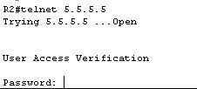

Here we have a snip of Router 2 in Mumbai accessing router 5 in New York.

**Test VLAN :**

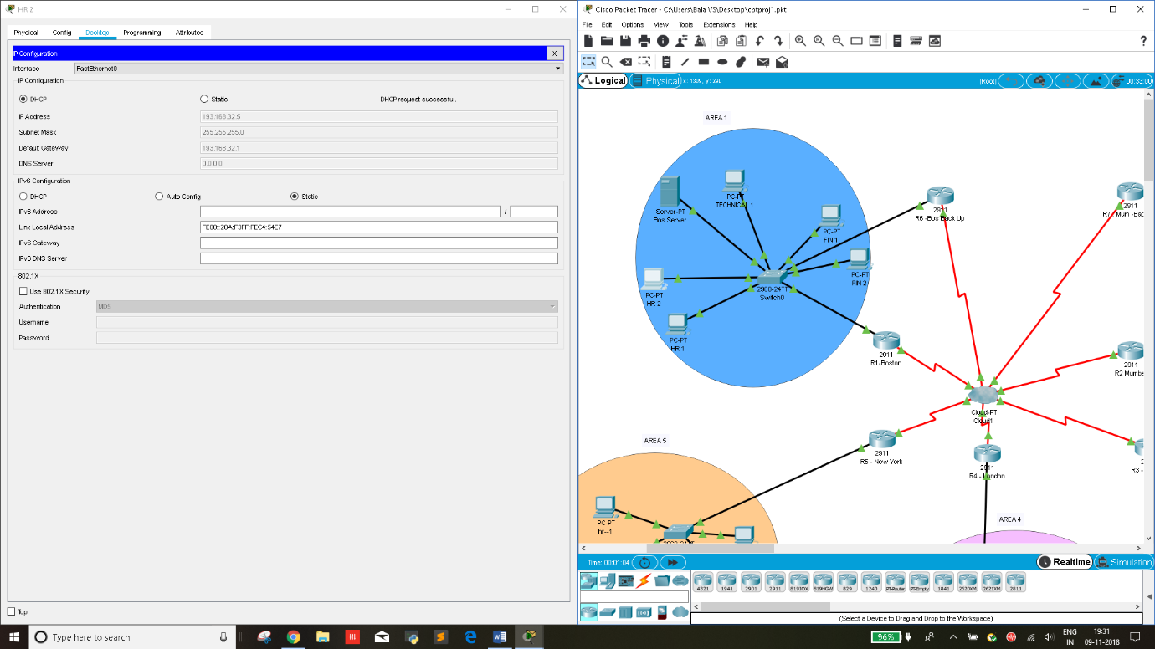

**Now disconnect both the routers and it is seen that APIPA is used and DHCP fails.**

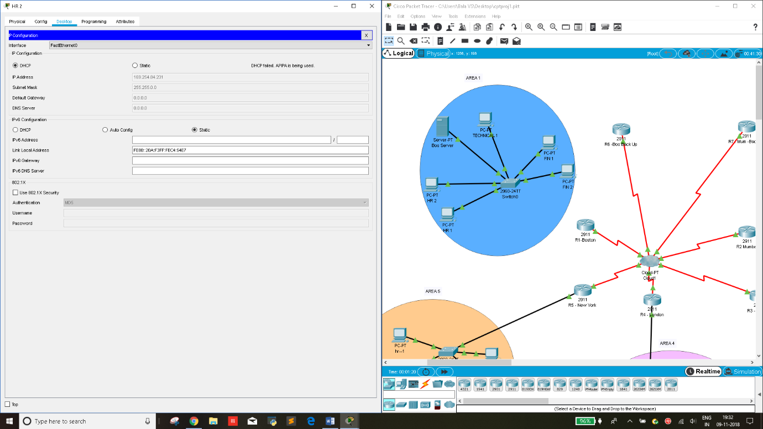

**Test Redudancy :**

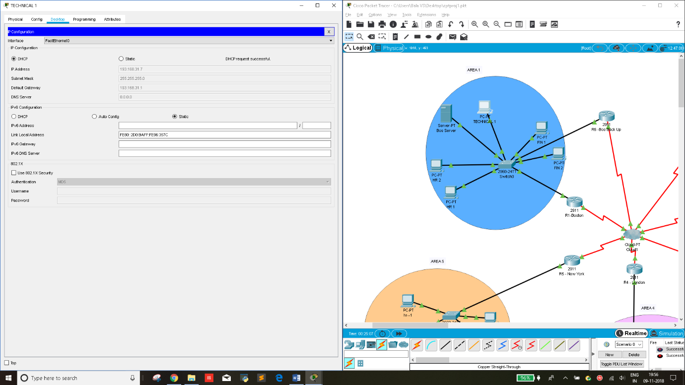

**Remove connection from existing router. Now backup router is active**

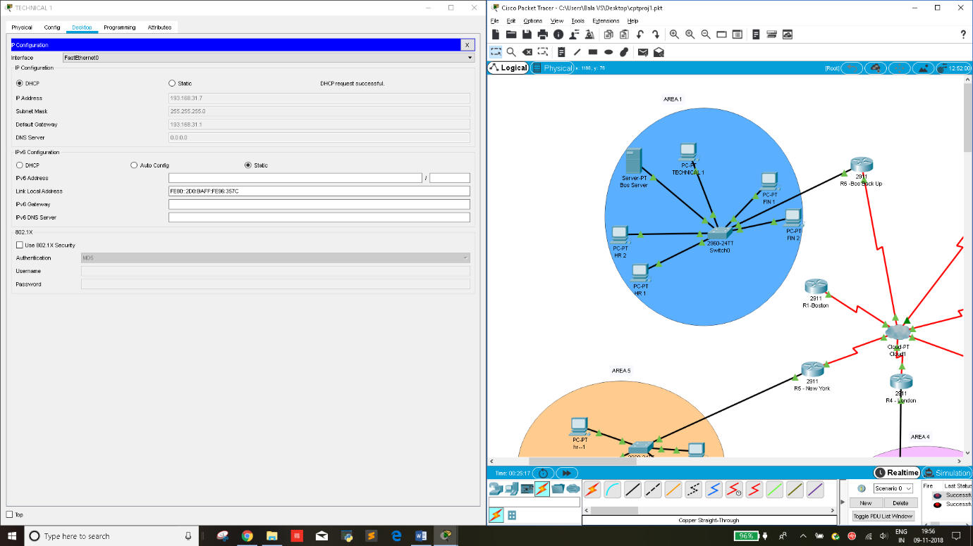

**Test to use one router to control all routers**

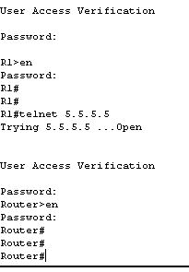

**Takeaway Questions :**

1. **OSPF vs RIP :**

If the network is small enough to have the number of hops to be less, then RIP is a better choice. It is simple enough to execute and takes lesser time to implement. It is using distance vector algorithm.

If the network however, is larger then OSPF using the Dijkstra algorithm is better because , routers will then be able to calculate where the packet should go according to the shortest path available.

1. **Importance of areas in OSPF :**

The network in general will have a lot of memory to deal with, a lot of bandwidth , a lot of traffic. By segregating the network into “areas” what we are doing is to split the pressure involved, thereby increasing the reliability of the network.

1. When the OSPF protocol was introduced , area 0 was the backbone network and the other areas were developed accordingly.
2. Types of LSA :

LSA Type 1 (Router LSA)

This type is router specific. They only occupy in areas where the router has a link to.

LSA Type 2 (Network LSA)

This type is created by the Designated Router. The DR has a link ID corresponding to the network segment which the router is connected to.

LSA Type 3 (Summary LSA)

This type is created by area border routers to advertise to other areas.

LSA Type 4 (Summary LSA)

This type is created by Area Border routers which contain routes to the Autonomous System Border Router ( ASBR )

LSA Type 5 (External LSA)

This type is created by ASBR that connects to networks outside of the Autonomous System.

LSA Type 6 (Multicast LSA)

This type of LSA is used for multicast applications.

LSA Type 7 (NSSA External LSA)

Type 7 LSA allow injection of external routes throug Not-so-Stubby-Areas (NSSA). Generally external routes are advertised by type 5 LSA but they are not allowed inside any stub area. That’s why Type 7 LSA is used, to trick OSPF. Type 7 LSA is generated by NSSA ASBR and is translated into type 5 LSA as it leaves the area by NSSA ABR, which is then propagated throughout the network as type 5 LSA.

**Concepts learned from the Project**

1. Vlan creation and DHCP IP addressing
2. OSPF
3. HSRP
4. Telnet
5. WAN config
6. Spanning-Tree Protocol
7. Router on a stick

**Conclusion :**

This project was implemented to provide efficient connection using OSPF protocol which allows routers to intelligently calculate the shortest path available. Further, the security and redundancy were enhanced by introducing HSRP and login passwords.